7 DAYS TRANSLATION GUIDE

Intro______________________________________________________________3
How to use_________________________________________________________4
RPG Maker codes___________________________________________________6
Visual Translations___________________________________________________7
Sending the translation and proofreading_________________________________15

Intro

Hi!
This guide will try to help you in translating the hit indie game 7 days.
The translation tool we’ll be using is the Non-destructive localization plugin by Sang Hendrix, along with Rambi’s 7 Days Language Assignment plugin.
This allows for the game to switch languages in options, and for images/videos/ui to be translated.
You don’t need to buy or install this tool, you’ll only need software to open the csv file.

You start with downloading the two files in the discord message (7DaysExtraTranslation.csv and game_messages.csv) and opening the second one in your software of choice.

Notice: the english (and dutch) version have spaces before and after “...”
Example: This is … an empty cup.
Whether or not you do this in your language, is your choice.

The entire game (with all the endings/secrets/etc) has about 20000 words and 2500 textboxes.

ALSO: there are a couple updates lines, along with the game achievements. These can be found in the #updated-text channel, but you can do these after finishing the two files.

If at any moment you’re not sure about what to do, you can dm me (daverthedave) on discord.

If you do not own 7 Days yet and would like a copy on Steam, just ask and I’ll send over a steam key.
All the translators and proofreaders will be credited in the game’s menu and end credits.

How to use

The actual translation is done in a csv flle. The first file you should open is game_messages.csv. This file includes all of the text in the game. You can open this file with Microsoft Excel, Google spreadsheets, LibraOffice Calc, etc. Be sure to change the language code to yours in column F.

In the spreadsheet, there are 3 main columns. Original, en, and your language. (in this case, dutch)
Original and English will be the same, and you’ll have to translate your language in the third column.
From line 5 to 31, it’s menu text. After that is the text in the game.
Keep in mind that the textboxes in 7 Days are quite small, and only have room for two lines of text. Try to keep the length of the english text.
DON’T remove any of the columns or rows.

Names
Column C is the name of the character. You don’t have to change this at all.
The highlighted boxes in the image are the names you can translate. Boxes D and E are the english name, F is where you translate. If a name stays the same in your language, just put the same name.
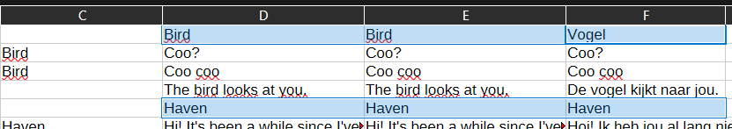

Empty Boxes
There are a couple of boxes you don’t have to fill in.

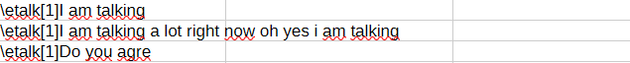
line 2-4

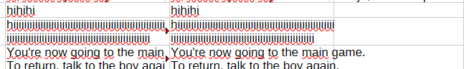
line 771-773

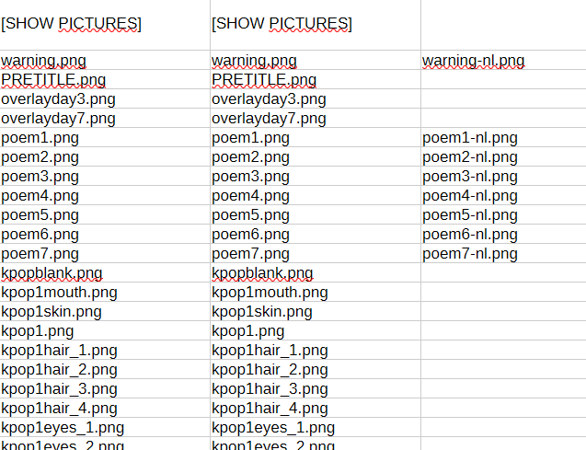
all the pictures, leave these empty.
from line 2670

RPG Maker codes

In RPG Maker, there are codes that change the way text is shown in game.
Please keep these in the translation, along with the same amount of spaces as in English.

\. is to wait ¼ of a second before continuing
\| is to wait 1 second before continuing
\! is to wait for player input before continuing
\c[1]save\c[0] is to change the color to yellow, and then to white. for example: \c[1]opslaan\c[0] in dutch

\etalk[x] is for the talking animation of a character. leave this at the front.

Visual translations
In addition to the spreadsheet, you’ll also need to translate a couple extra things.
You can translate these in the second excel file given in column B.

- Content warning screen

Content Warning
This game contains themes and imagery that may be distressing to some players.
It includes depictions of drug use, tobacco use, trauma, abuse, suicide, anxiety, gore, loss of close ones, difficult parental relationships, and attachment to past relationships. There are also bright flashing lights/colors that may affect players with photosensitive epilepsy.
Player discretion is advised.
For the best experience, it is recommended to play the game in windowed mode.

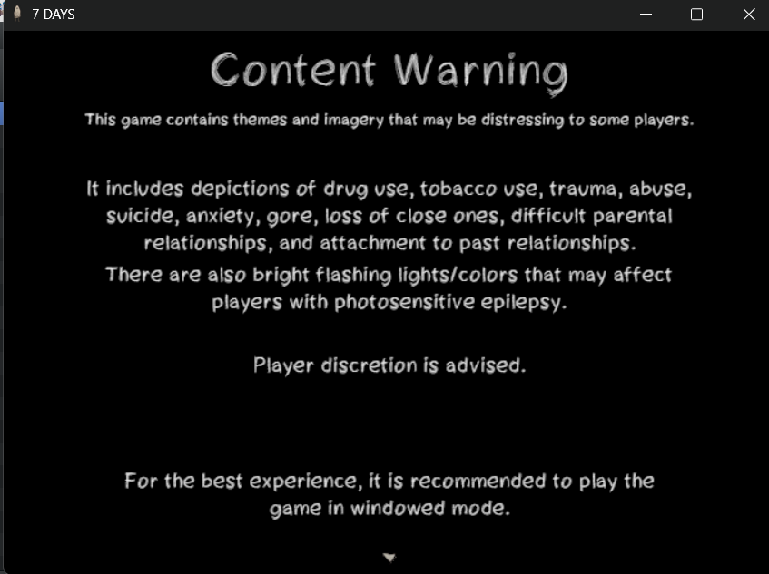

- "Interact" text in prologue/tutorial (guiding to interact with object)
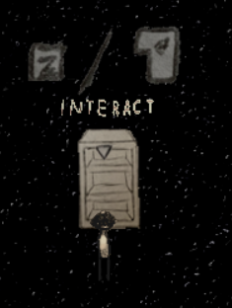

- "Day 1" "Day 2" "Day 3" ... "Day 7" (title card between each day)
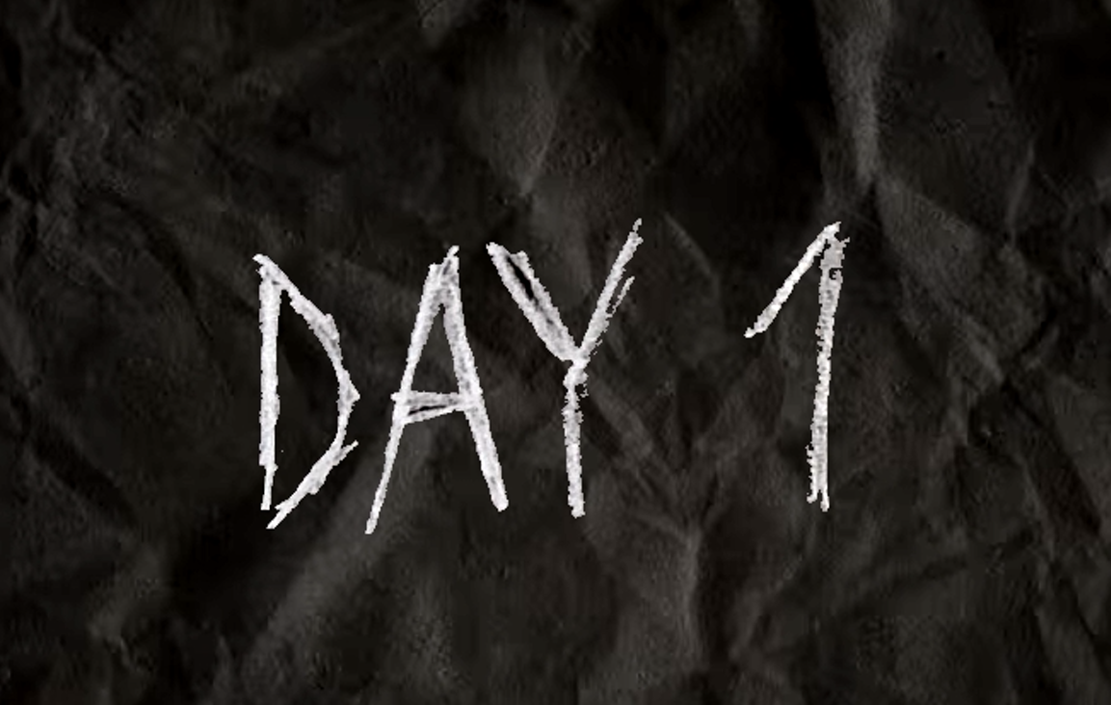

- "7 DAYS" "6 DAYS" "5 DAYS" ... "1 DAY", THE END, WAS THIS WORTH IT, IS THIS IT (window name)


- 3 Jumpscare texts in video (don't go there, you're not ready, this is my sanctuary)
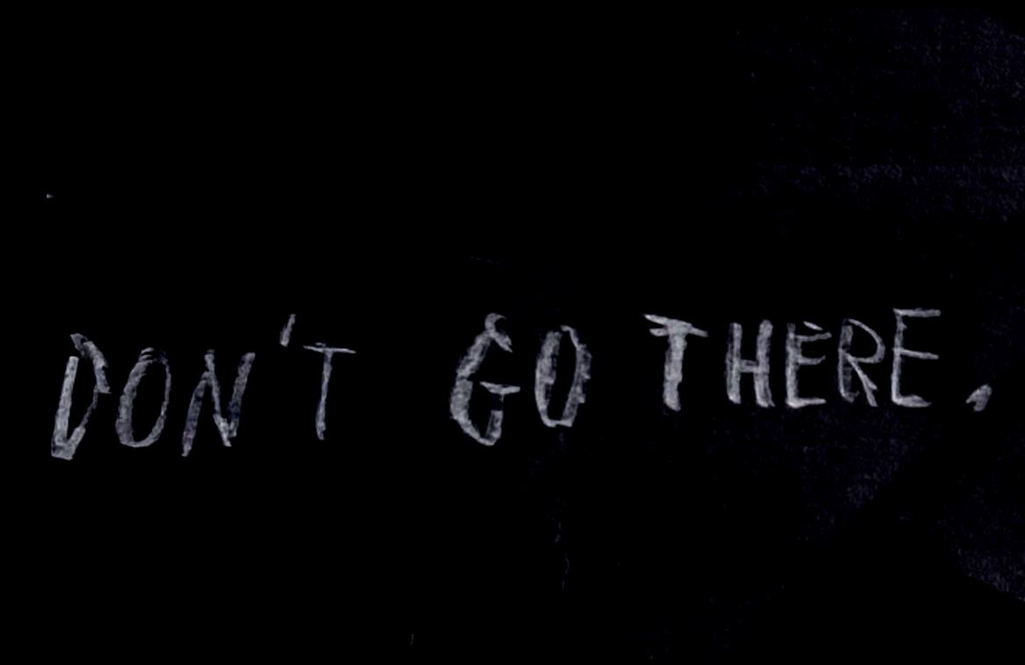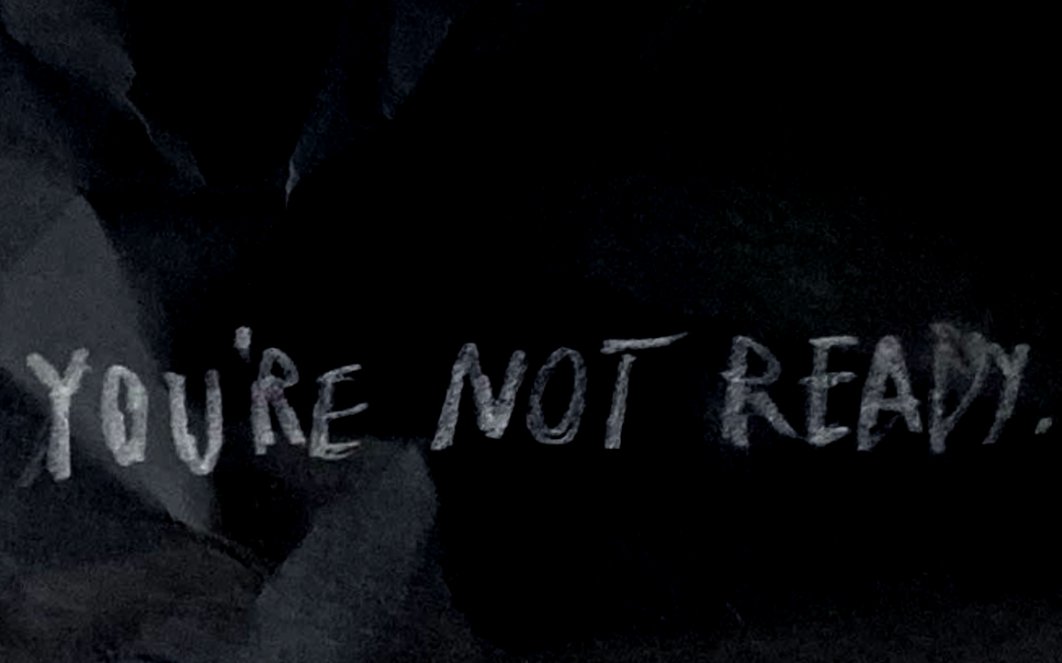

- 2 of the School blackboards in day 2 (I was here/Stinky)
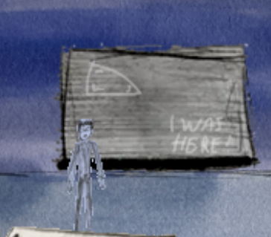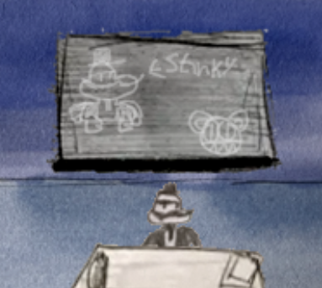

- School signs (Music, Library, Gym, Teacher's lounge, Courtyard, janitor's closet)
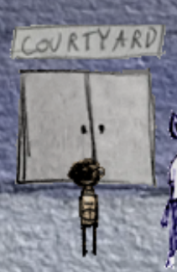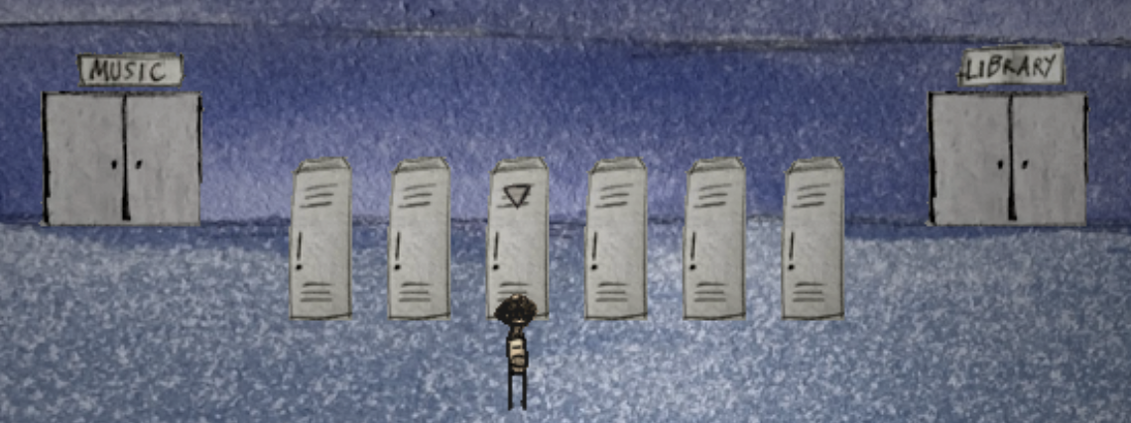

- The 7 poems in day 2
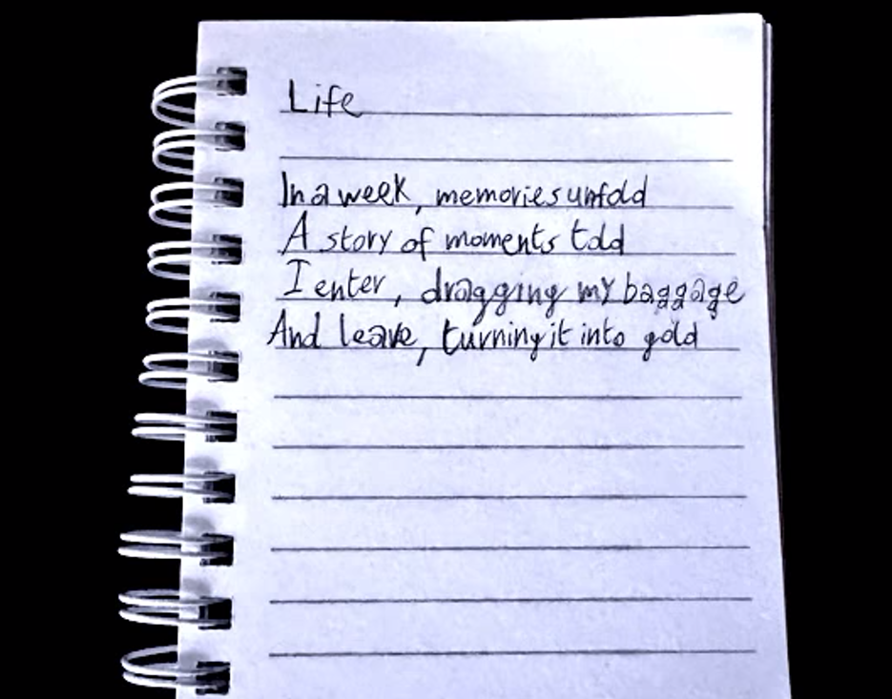

- Past memories nightmare video
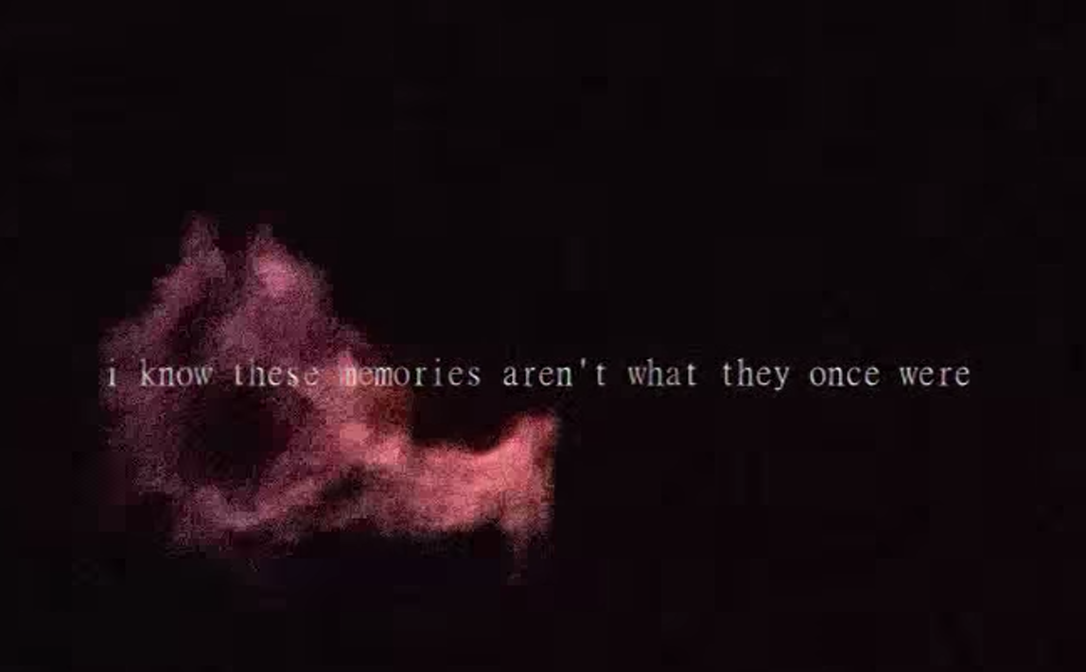

- text of day 3 nightmare (it was your fault, you did this)
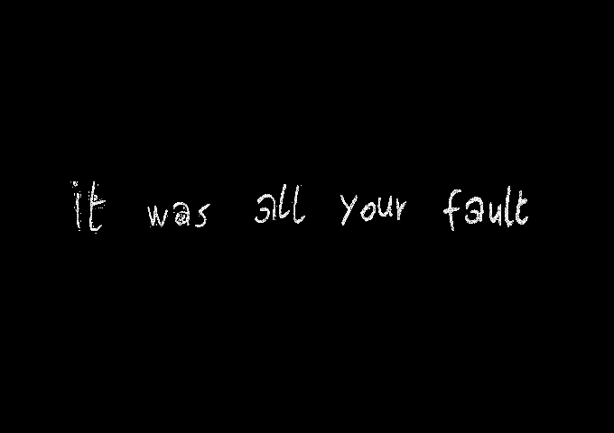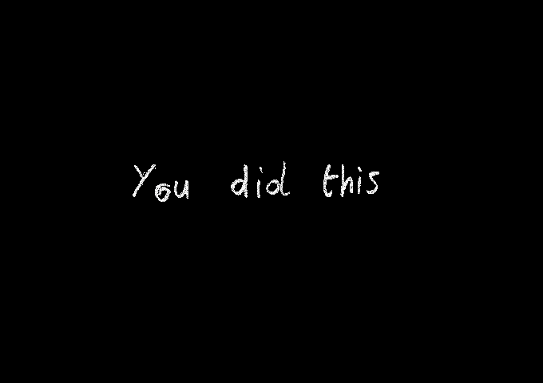

- Cat City sign when entering
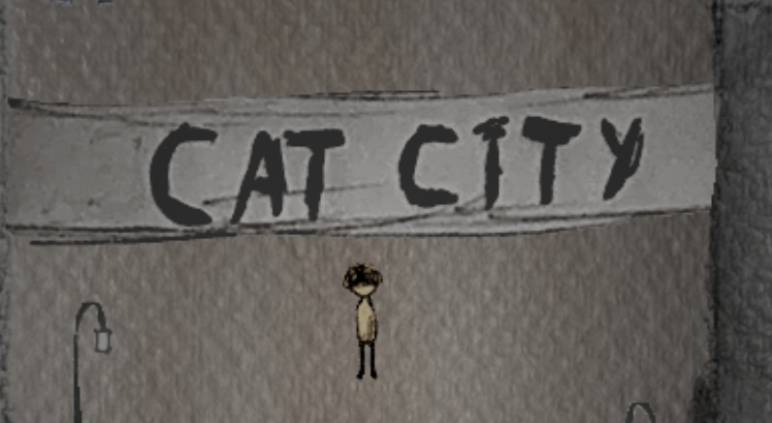

- Cat Cafe sign outside building
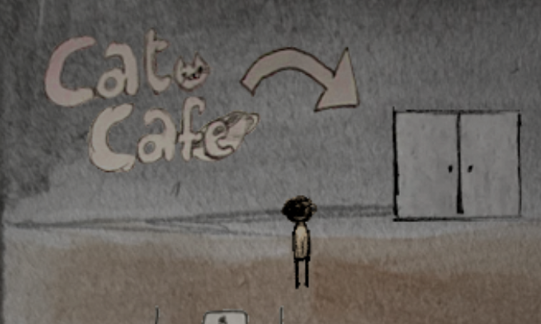

- Cat City bakery sign
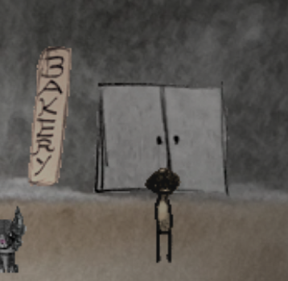

- Cat Cafe minigame instructions
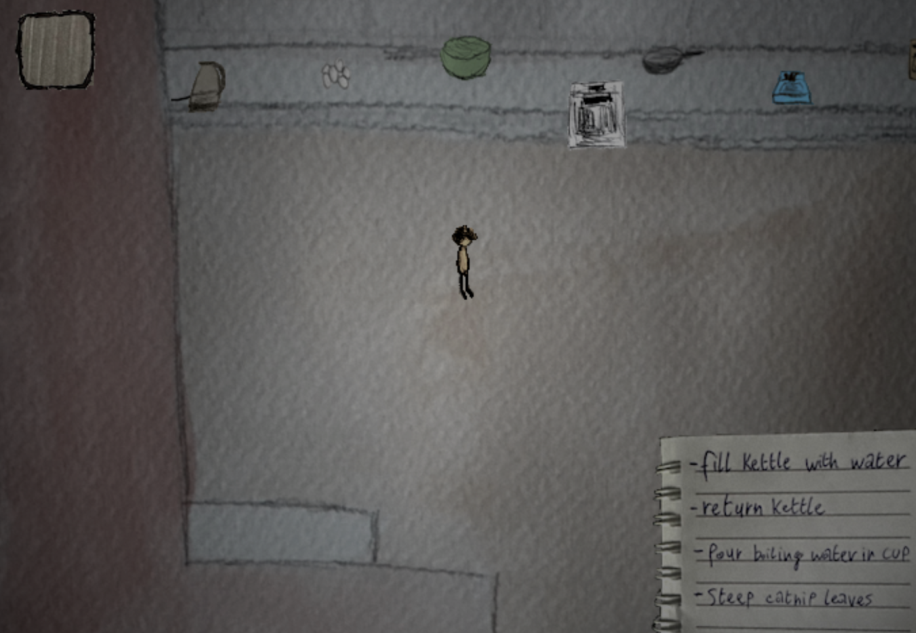

- Tuna visual in minigame
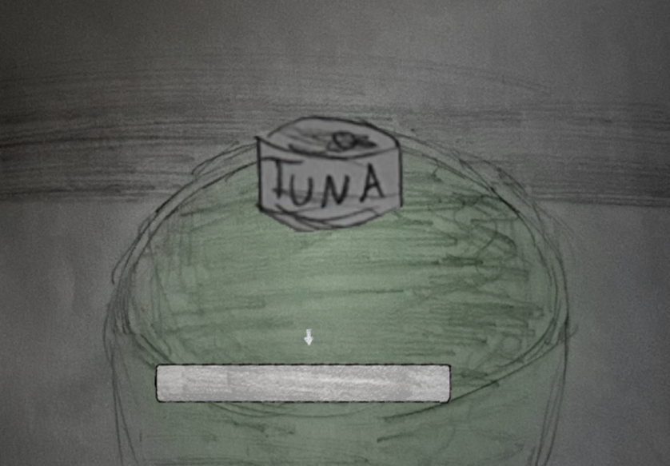

- Cat City logo in arcade
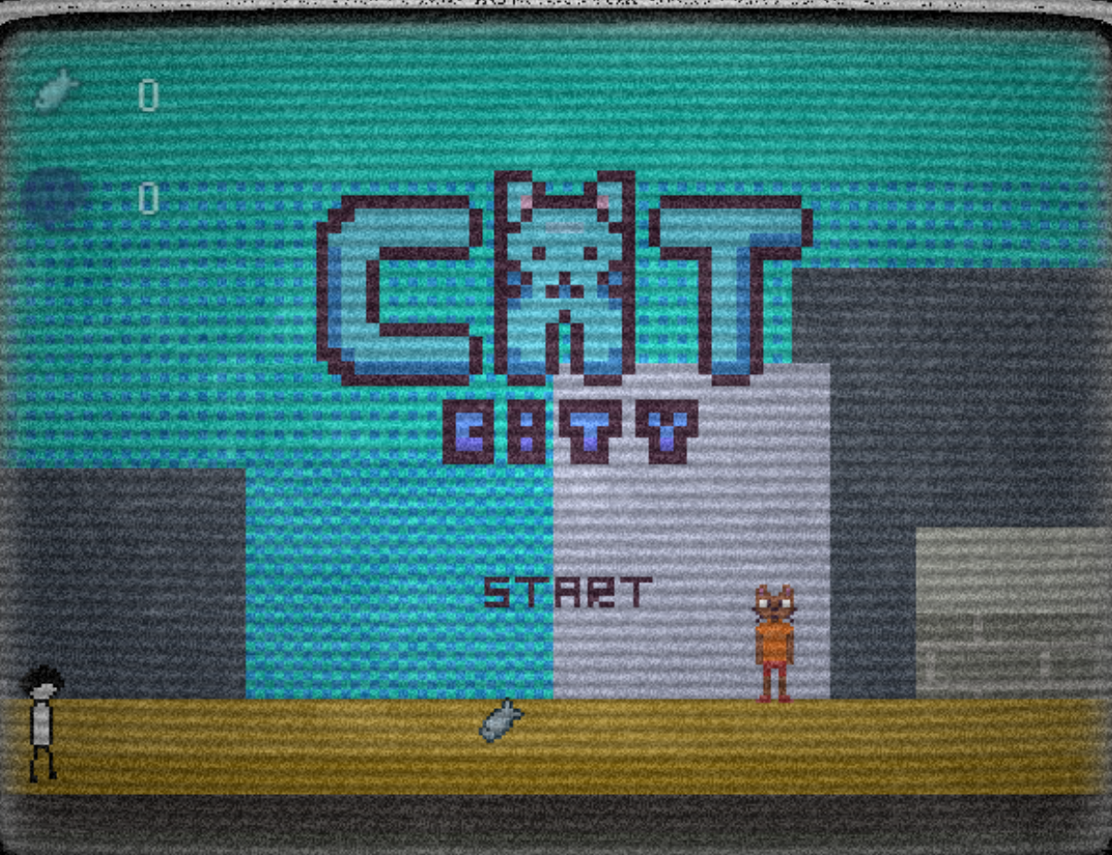

- I want 15 fish! in arcade
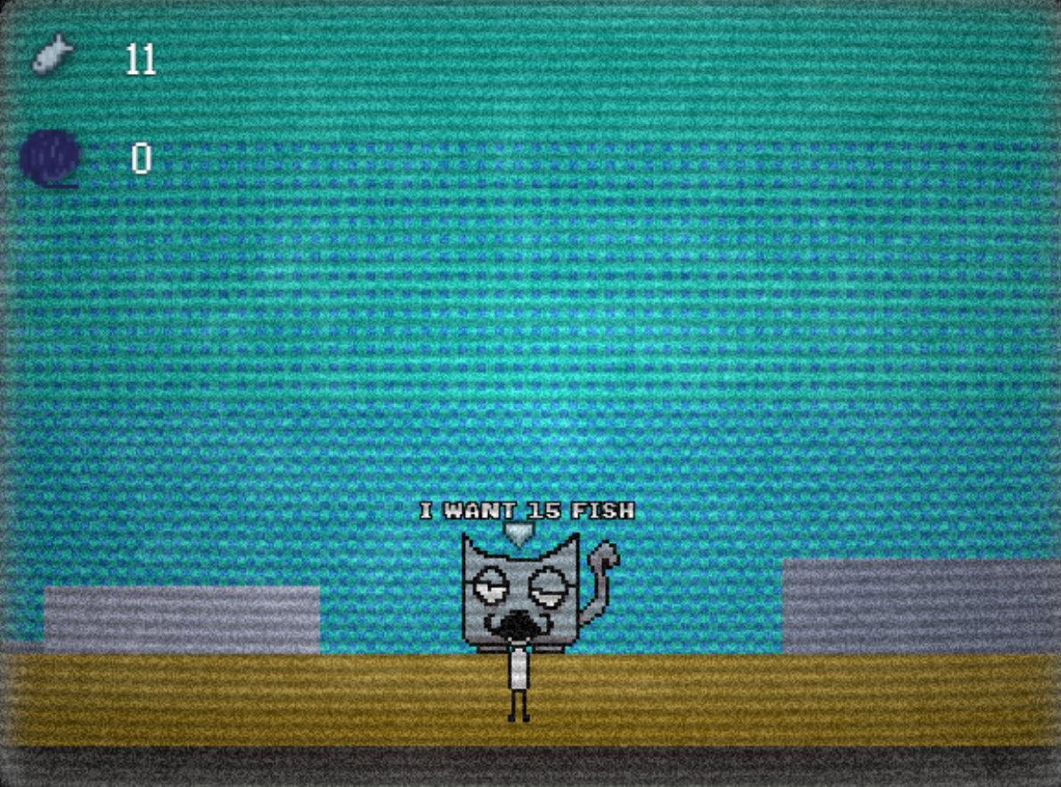
- Day 4 end cutscene
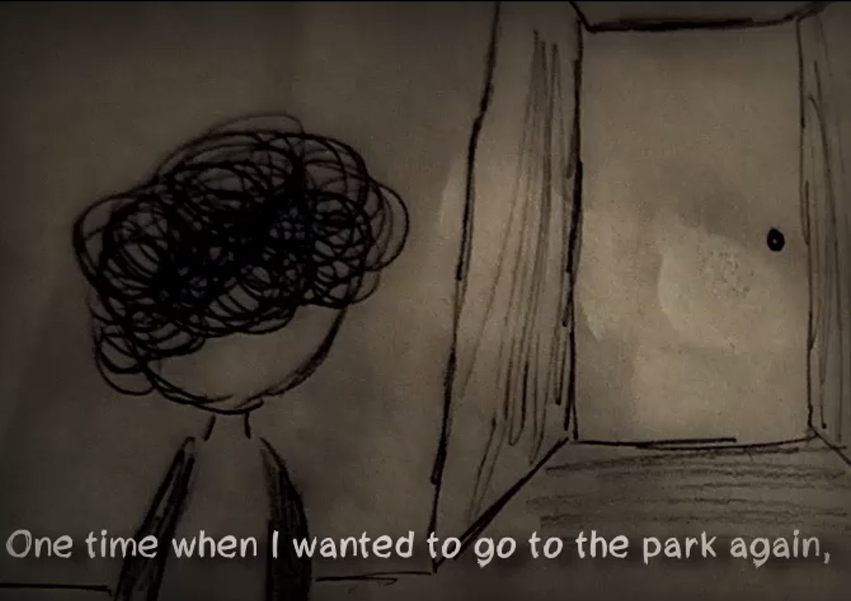

- All text in day 5 cutscenes
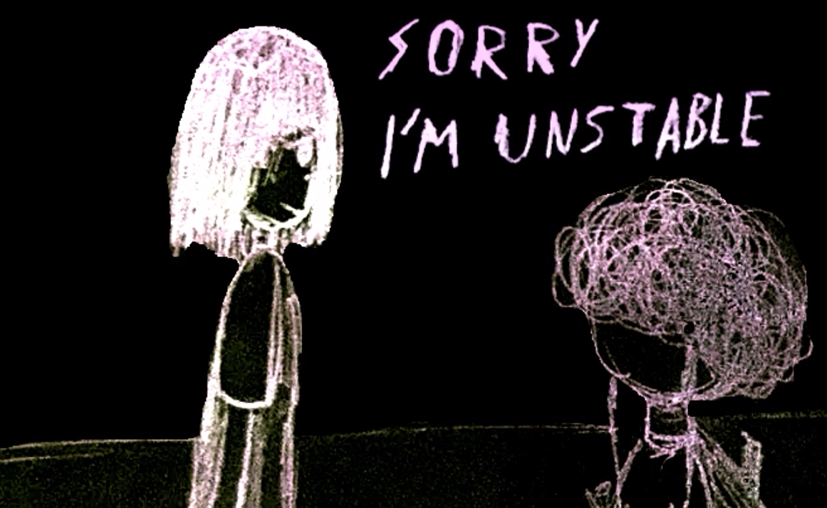

- Haven "Hi!" email in day 5
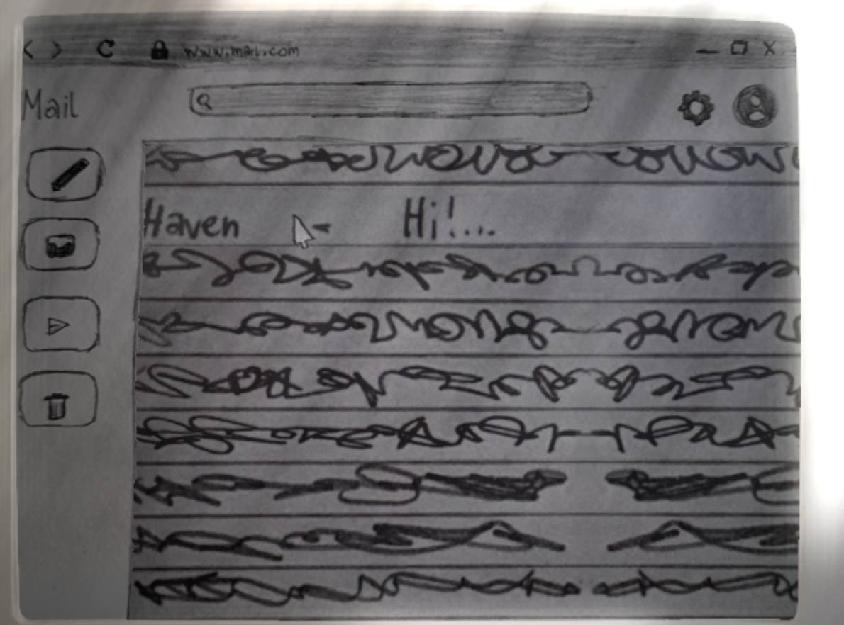

- Juice in day 5
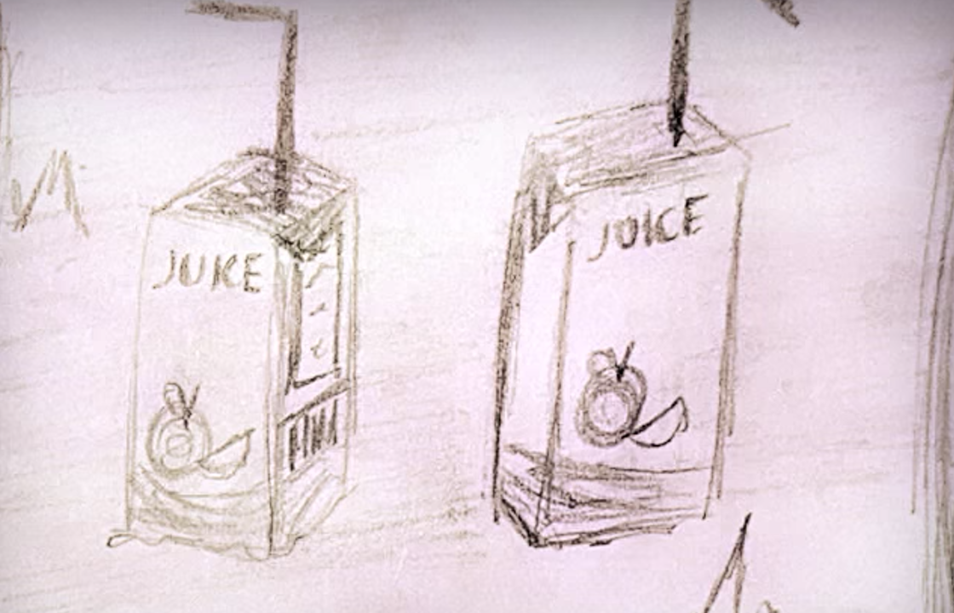

- Papers in day 6 maze (good and bad route)
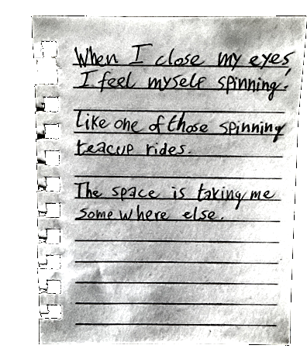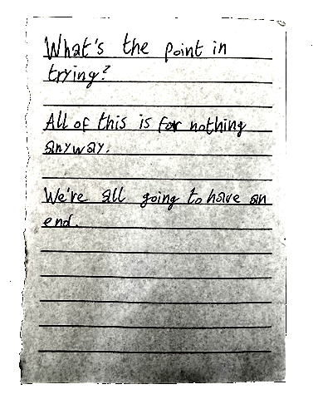

- words on drawings in day 6 (Cool cards, Dumb, Stupid, Shadow, Die) (page 2, 4, 5 and bad 3, 4, 5)
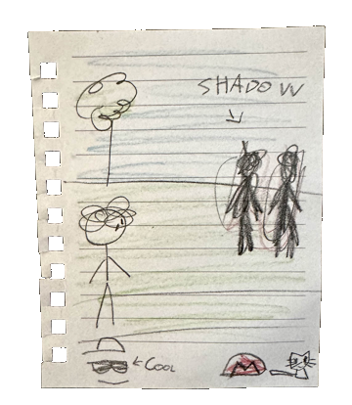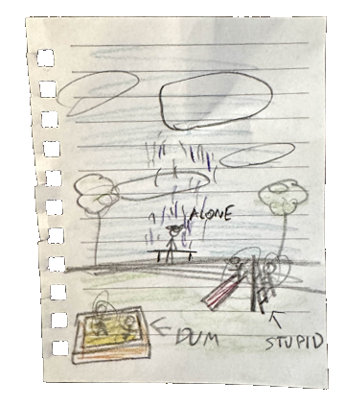

Sending the translation and proofread

Once you are done with the translation, you should have:
-The main translation spreadsheet (add your language in the file name)
-The extra translation file (add your language in the file name)

Send these to me (daverthedave) on discord. I’ll put all the translations together and
send a playable version to the translator and proofreader.

I’d suggest dming (in groups of more than 3 people) with the translator/proofreader if there are any mistakes/errors found. Let me know if there’s any changes needed.

If there is not a proofreader available, just send the files to me and I’ll send you the downloadable version.



